**Project Design Phase-II**

|  |  |
| --- | --- |
| Date | 11 October 2022 |
| Team ID | PNT2022TMID14269 |
| Project Name | University Admit Eligibility Predictor |
| Maximum Marks | 4 Marks |

**Data Flow Diagram & User Stories**

**Data Flow Diagrams:**

A Data Flow Diagram (DFD) is a traditional visual representation of the information flows within a system. A neat and clear DFD can depict the right amount of the system requirement graphically. It shows how data enters and leaves the system, what changes the information, and where data is stored.

**LEVEL 0**  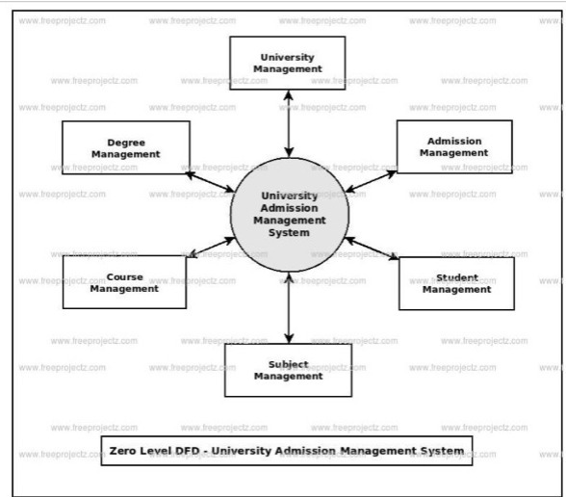

**LEVEL 1**

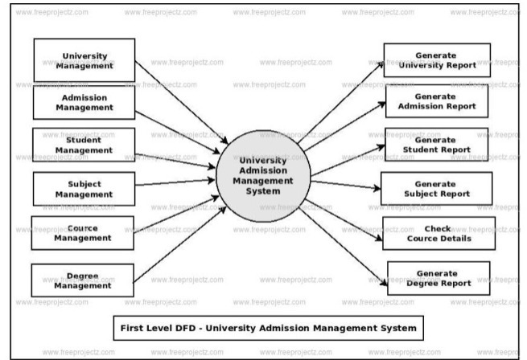

**LEVEL 2**



**User Stories**

Use the below template to list all the user stories for the product.

|  |  |  |  |  |  |  |
| --- | --- | --- | --- | --- | --- | --- |
| **User Type** | **Functional**  **Requirement (Epic)** | **User Story**  **Number** | **User Story / Task** | **Acceptance criteria** | **Priority** | **Release** |
| Customer  (Mobile user) | Registration | USN-1 | As a user, I can register for the application by entering my email, password, and confirming my password. | I can access my account / dashboard | High | Sprint-1 |
|  |  | USN-2 | As a user, I will receive confirmation email once I have registered for the application | I can receive confirmation email & click confirm | High | Sprint-3 |
|  |  | USN-3 | As a user, I can register for the application through Facebook | I can register & access the dashboard with Facebook Login | Low | Sprint-2 |
|  |  | USN-4 | As a user, I can register for the application through Gmail | I can register for the application through Gmail | Medium | Sprint-1 |
|  | Login | USN-5 | As a user, I can log into the application by entering email & password | I can log into the application by entering email & password | High | Sprint-1 |
|  | Dashboard | USN-6 | Related to profile | Information regarding score cards | High | Sprint-2 |
| Customer (Web user) | Register | USN-7 | By giving all the personal details | Provides the personal details for the user | High | Sprint-1 |
| Customer Care Executive | Toll free number | USN-8 | Provided in the website | For queries | Low | Sprint-4 |
| Administrator | Via email | USN-9 | Confirmation through email | Conforming | High | Sprint-3 |